Illustrator Leaves to 24 Pixel Size

Create the Image section6
Have Copilot create a vector type image.
Pull that Image into Illustrator
Turn the first layer into a Template Layer
Add another layer to add artwork to, do not worry about multiple layers Illustrator will sub layer stuff
Take the pen tool and trace around the image, the different sections.
Go to Appearance Panel, Select Each section to add color to them individually
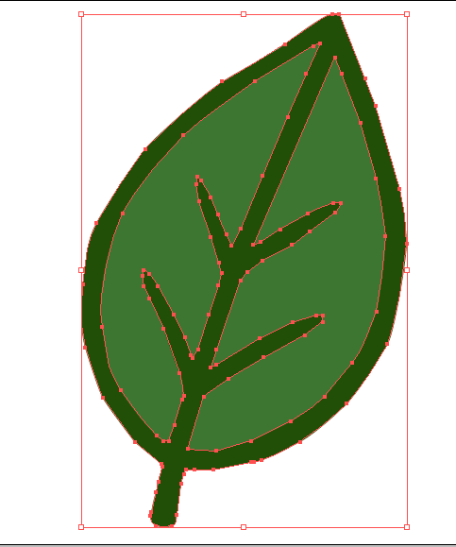

To Shrink the image to a 24 to 24 px image after doing the work
Go to the top Menu File-Document Setup
Set Units to Pixies, Go to Edit Artboards
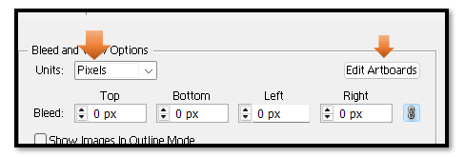
Once in the art board set it to 24 x 24
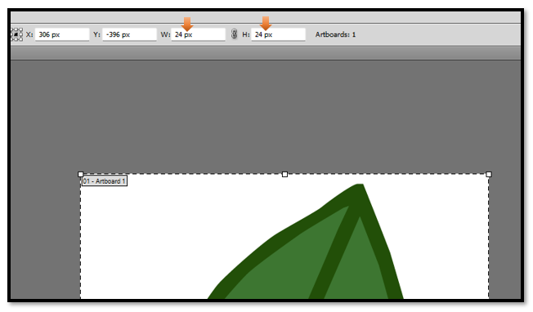
Just hit another tool in the left panel to come out of the Artboard.
Then shrink the image down to fit in the board.
Save as SVG and png, even your pngs will look better at this size. Look at these png images

